WEB TECHNOLOGY PROJECT

**ONLINE BOOK STORE**

**Done by,**

Kaviya. N - 2018506051

Losshika. S. N - 2018506058

Poovithal Rama - 2018506077

**ONLINE BOOKSTORE**

**INTRODUCTION:**

The Online Book Shopping Store is designed to manage, buy, add, remove and sell books. Searching, Book name and Quantity selection, discount and payment options are made available. Viewing orders, Login and logout security for both user and admin are provided. Separate Profile for all.

**MODULES:**

* Home
* Registration
* Login
* Admin Activities**:**
  + Admin page
  + View Books
  + Add book
  + Remove book
  + View users
  + Edit stock
  + View orders
* User Activities:
  + User page
  + Search book
  + Select book and quantity
  + Cart
  + Confirm and buy
  + Order address
  + Mode of Payment

**HOME:**

This module displays the homepage of the website with title and motto of the bookstore along with three buttons which provides the registration and login options.

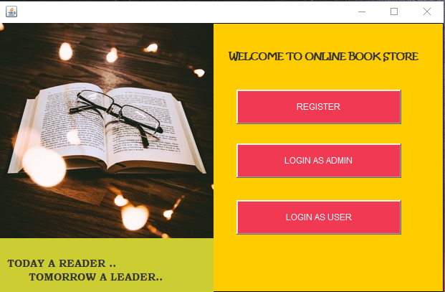

**REGISTRATION:**

This module allows user to create an account with the bookstore. This page has many entry fields where the user can enter the required details. The details are validated and ensured that no field is left empty. The user details are stored in the database.

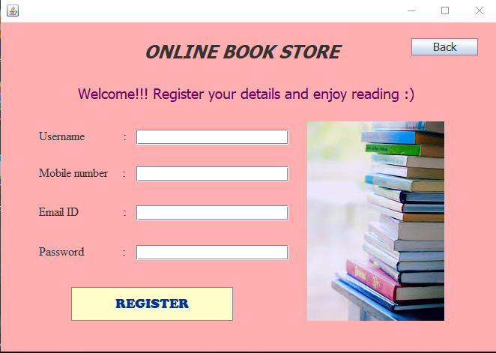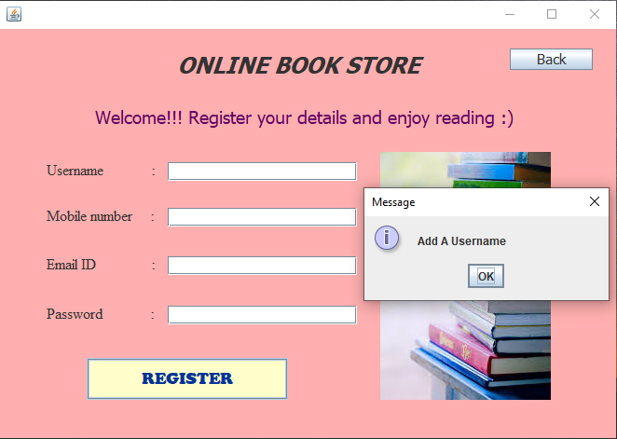

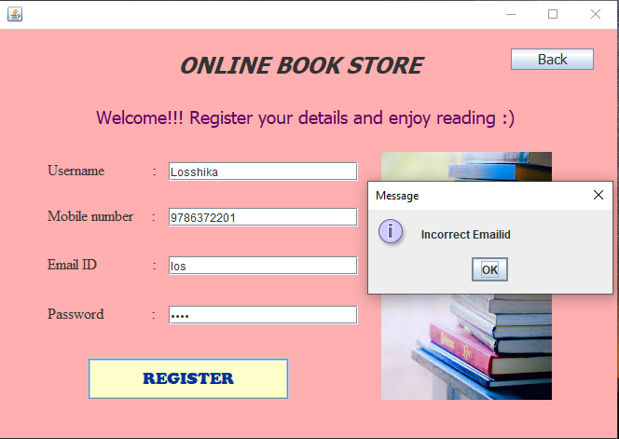

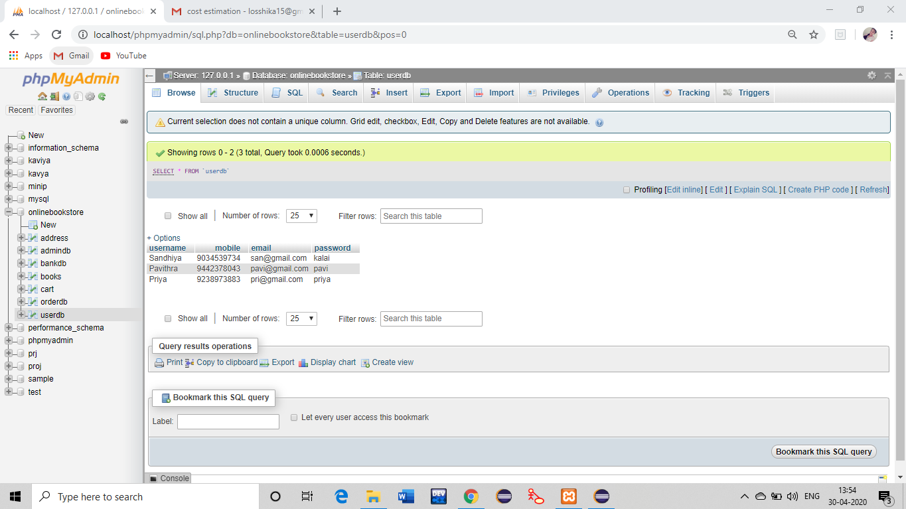

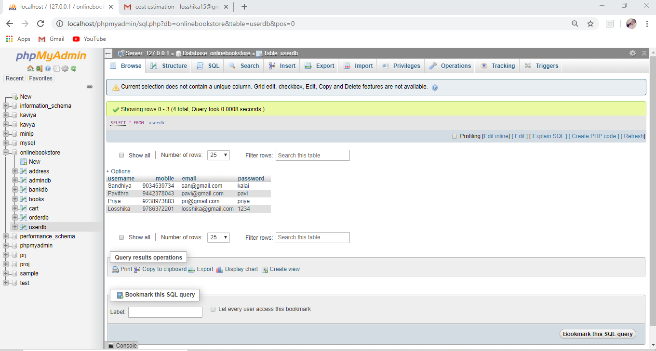

**LOGIN:**

1. **ADMIN LOGIN:**

The admin has to click on ‘login as admin’ button in the home page. As the login page is opened and if the entered credentials match with the values in database they are allowed to access the admin page.

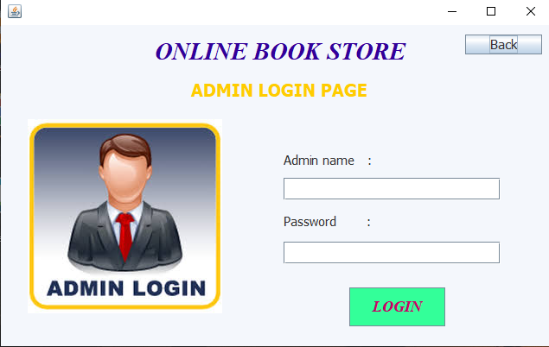

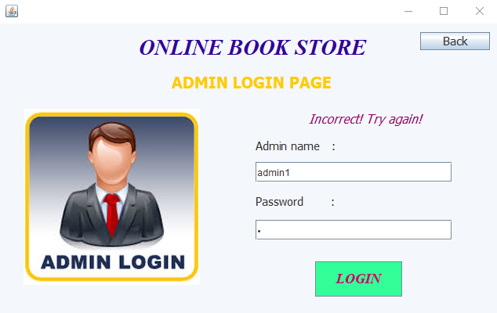

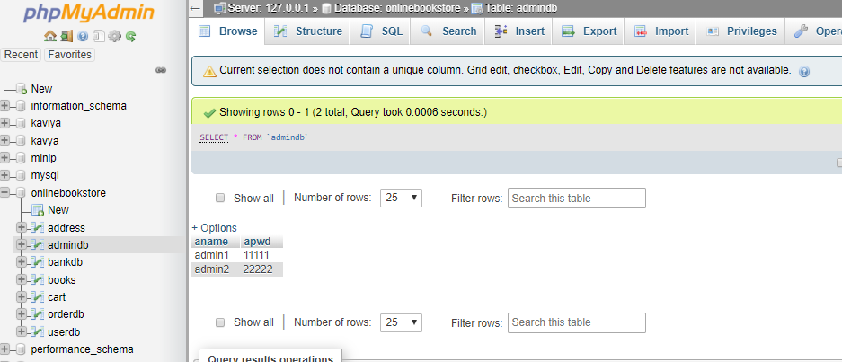

**ADMIN PAGE:**

This page has buttons along with pictures for better interaction which on click allows admin to View books, orders and users, add or delete book and manage stock. The logout button allows the admin to sign off and redirects him to the homepage.

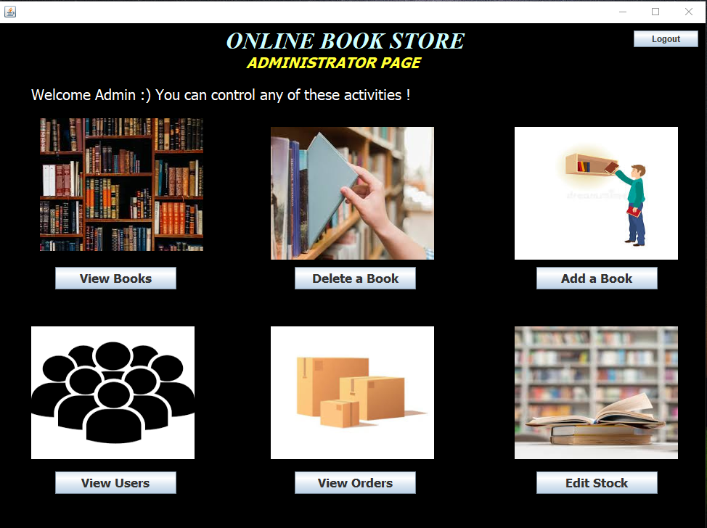

**VIEW BOOKS:**

This page is designed with jtable which displays the available books in the store and their respective authors, genres, quantity, price, rating.

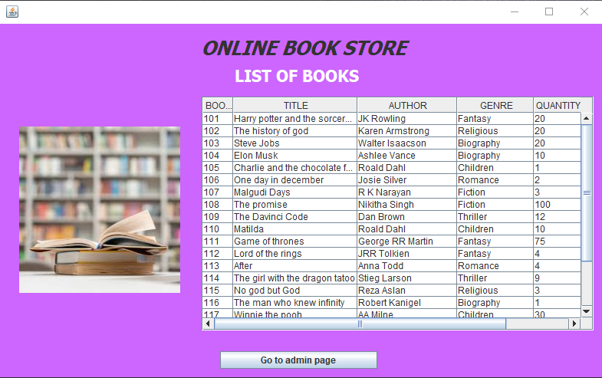

**ADD A BOOK:**

When the admin wants to add a new book in his store he can provide the details of the book in the entry fields that are displayed in this page. He also has to provide an image of the book. No entry field can be left empty.

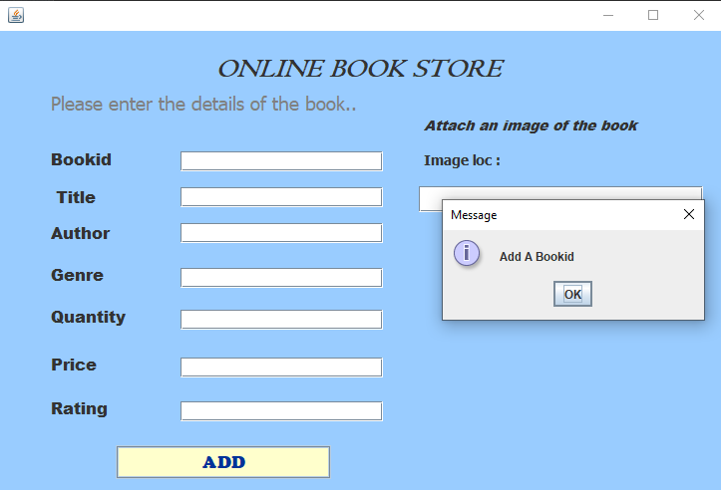

The entered details gets added to the books table.

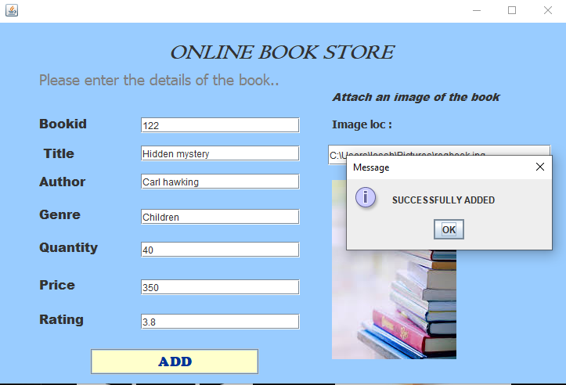

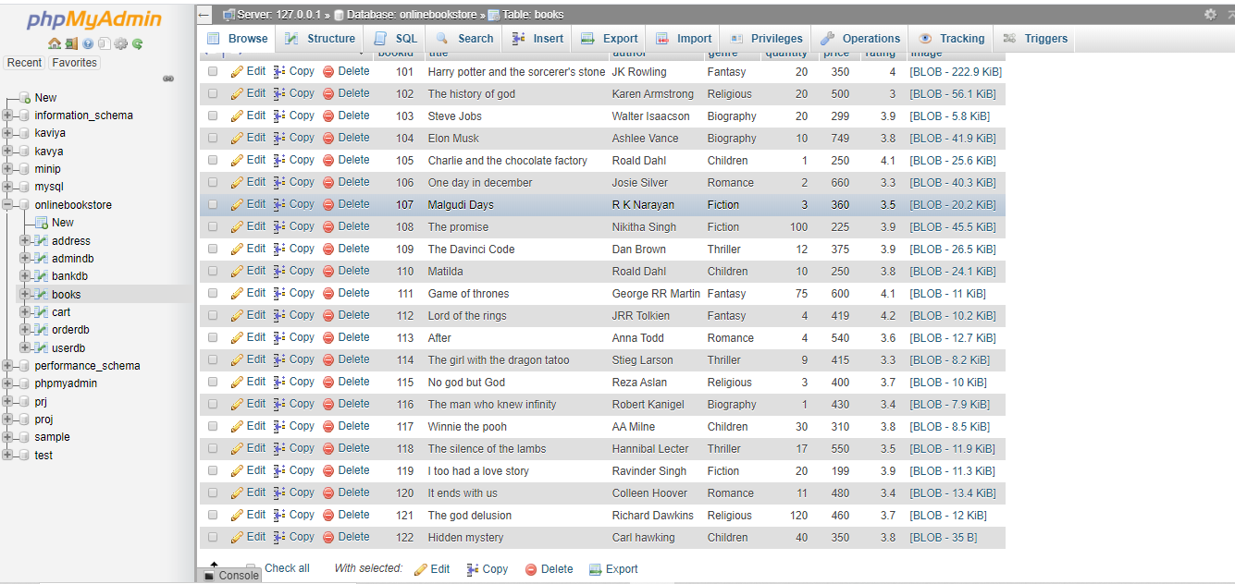

**DELETE BOOK:**

If the admin wants to remove a book from the list of available books he can do so by clicking on ‘delete book’ button. When he enters the bookid of the required book in the text field that book in the ‘books’ table.

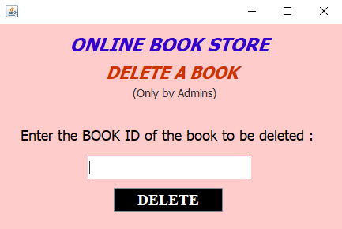

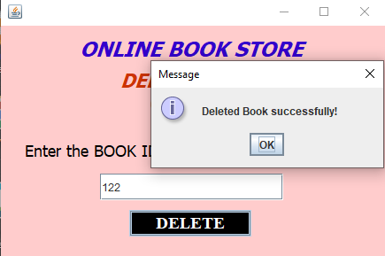

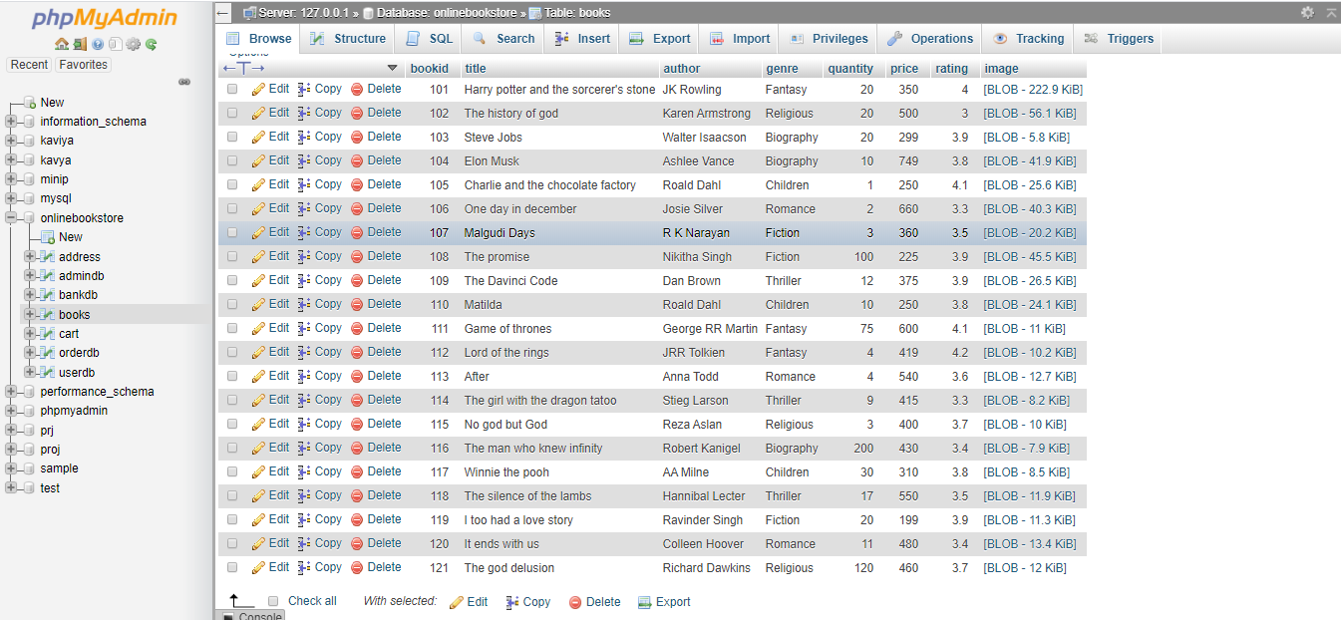

**VIEW USERS:**

On clicking the ‘view users’ button, admin can view the users who have registered with the bookstore. It is displayed in the Jtable along with their details.

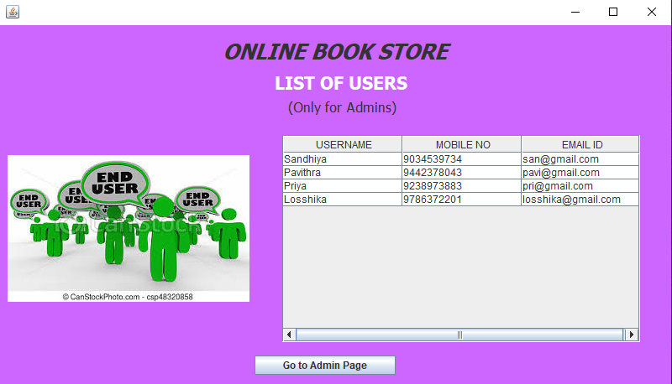

**VIEW ORDERS:**

On clicking ‘view orders’ button, admin can view all the orders placed by the customers. It is displayed in a jtable along with the book’s details ordered by the users.

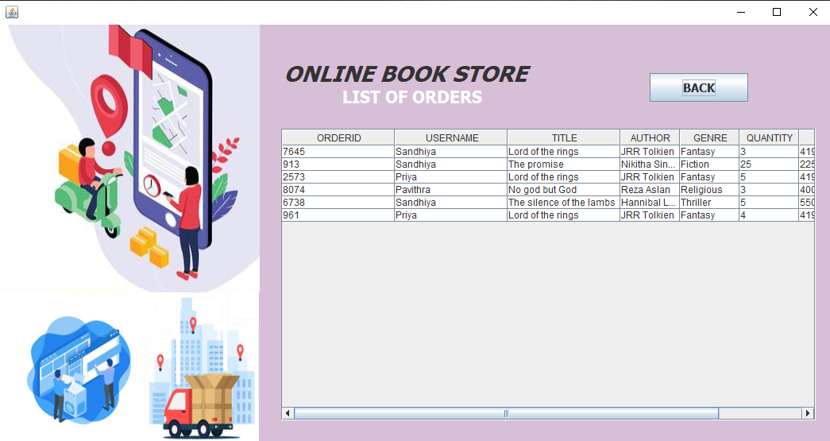

**EDITSTOCK:**

If the admin wants to update quantity of the available books, he can do so by clicking on the ‘Edit Quantity’ button, which invokes a popup window where he should enter the bookid and quantity and then the quantity column of books table is updated.

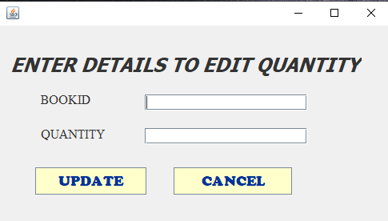

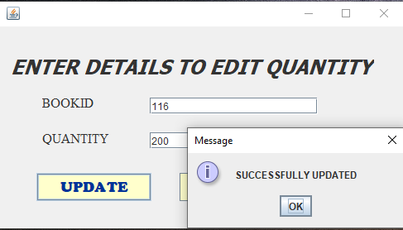

1. **CUSTOMER LOGIN:**

The customer has to click on ‘login as user’ button in the home page.

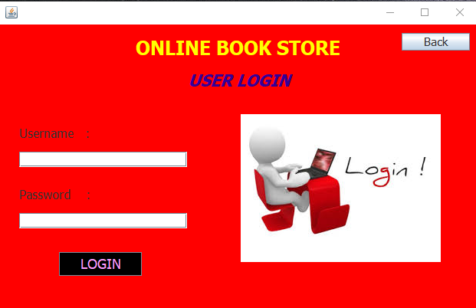

As the login page is opened and if the entered credentials match with the values in database they are allowed to access the user page.

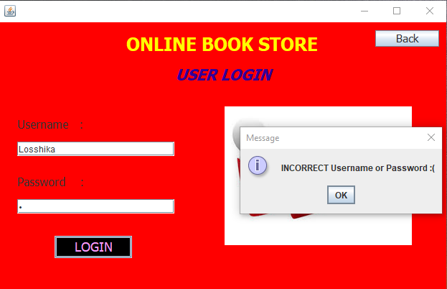

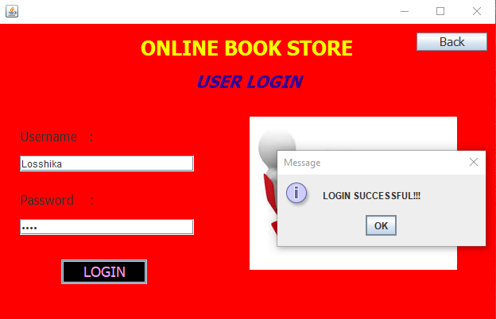

**USERPAGE:**

Once the login is successful, user page is displayed. This page displays some of the best-selling top rated books from the store along with book’s author, genre, price, and rating.

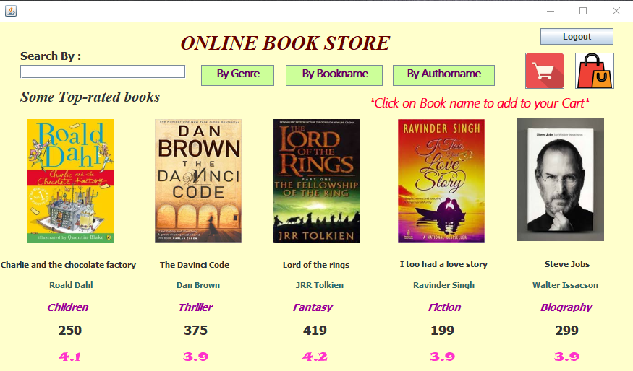

The user can search for a particular book using book name or search books by their genre or author name by entering it in the text field provided.

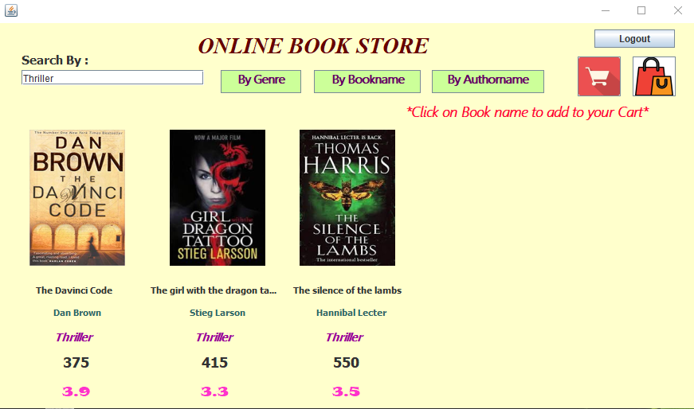

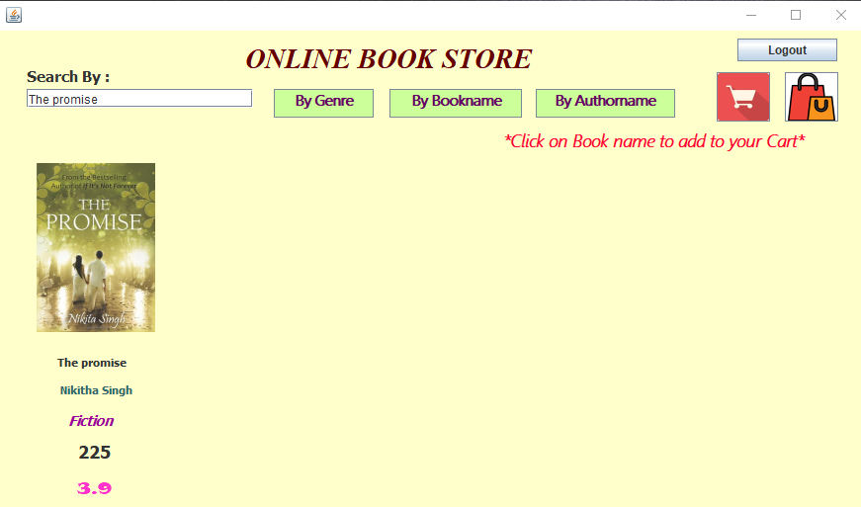

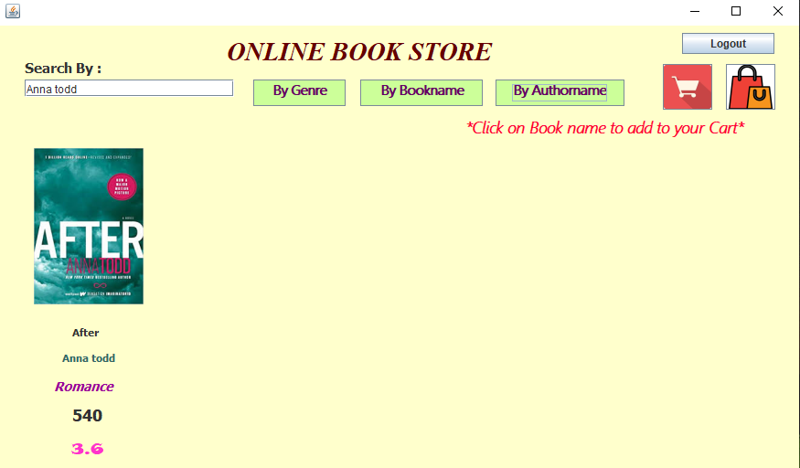

If the user has selected the book of his choice he can click on the book’s name. On clicking a pop up asks for the count of books he want. The book gets added to the cart he can continue shopping.

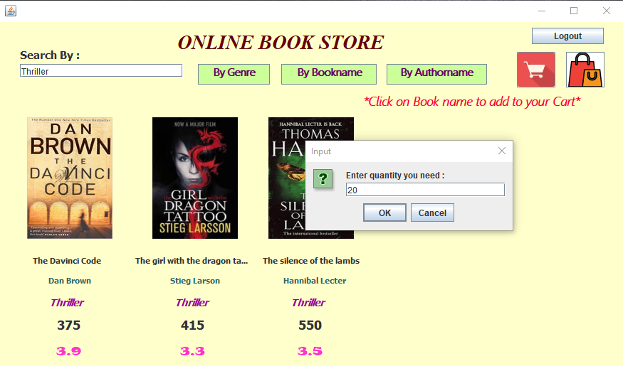

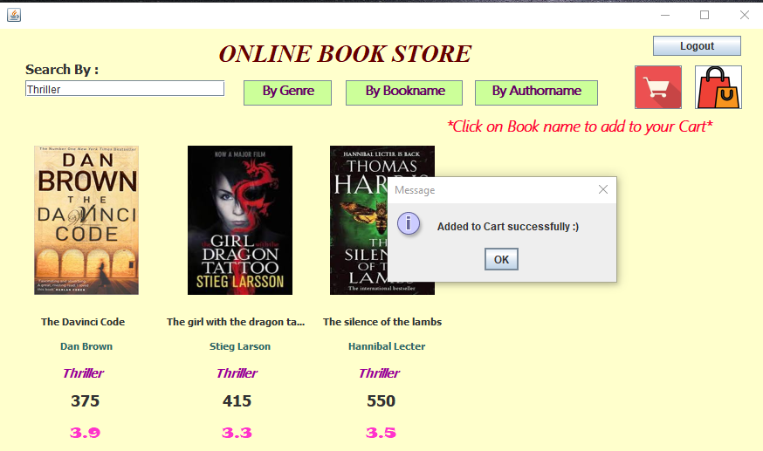

He can view the cart or logout or view his history of orders from the page by clicking on the respective buttons on the top right corner.

**CART:**

Here the customer can view his selected books along with their details. In this, the different discount offers available for the users are displayed on one side of the page. The total no of books, total quantity and the total cost of books are calculated by retrieving the data from the ‘cart’ table and is displayed on the screen. The customer can proceed to buy the books by clicking on ‘order and pay’ or click on ‘back’ button.

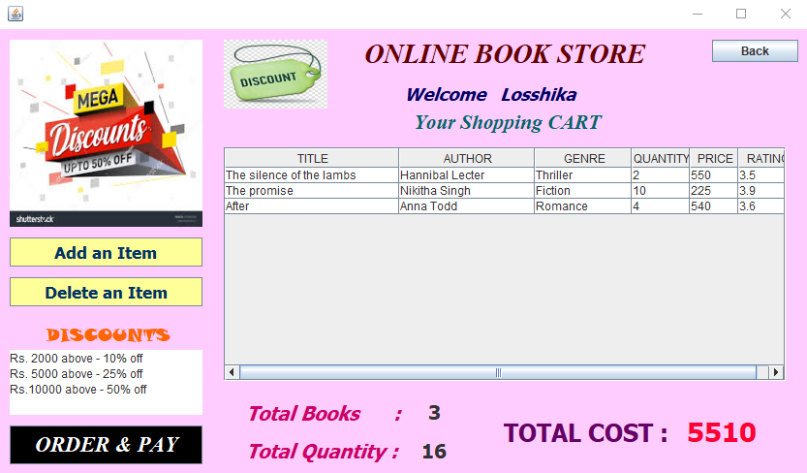

The customer can click on ‘Add an item’ button if he wants to add more books .

The customer can click on ‘delete an item’ if he want to remove a book from cart.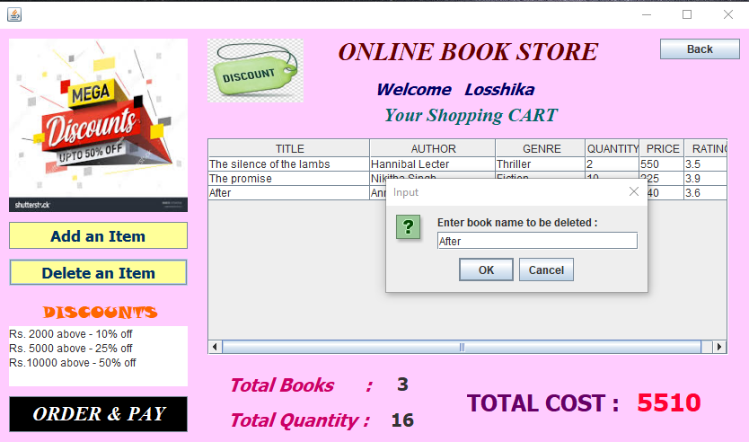

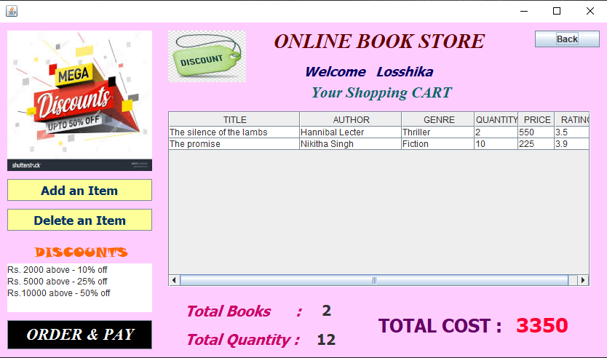

Deletion updated CART DB:

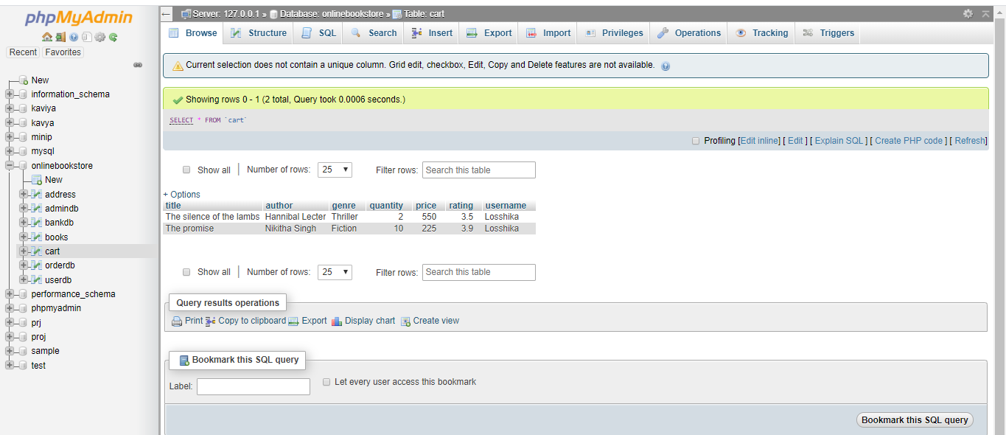

**ORDER ADDRESS:**

The details of the order placed is displayed on one side of the page. The user have to fill in his details of the delivery address. The text fields are validated and ensured that no field is left Empty.

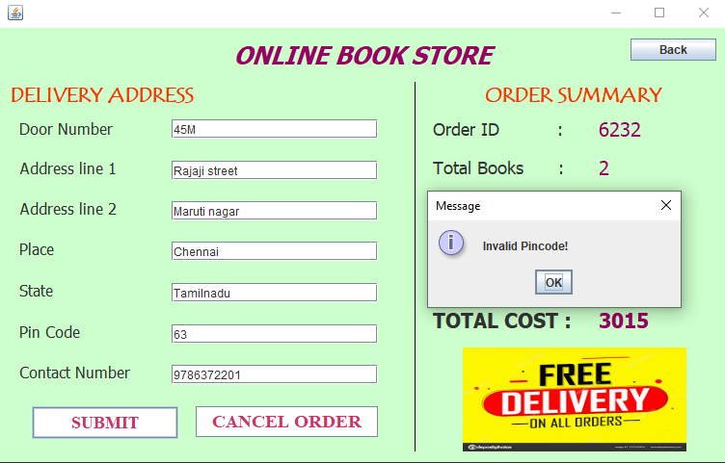

He can then click on ‘submit’ button to proceed to payment and the details are entered into ‘address’ table or cancel the order by clicking on ‘cancel’. The date is also recorded.

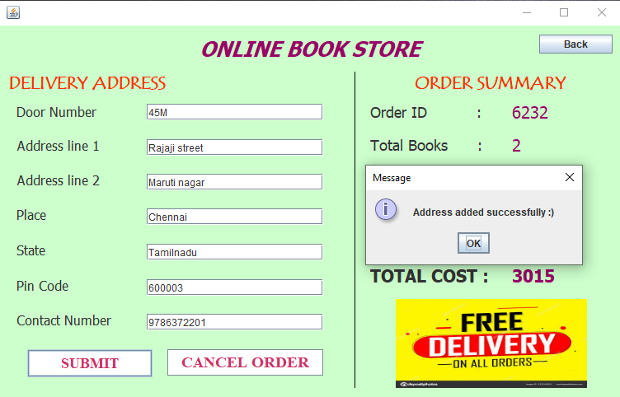

Updated Address DB:

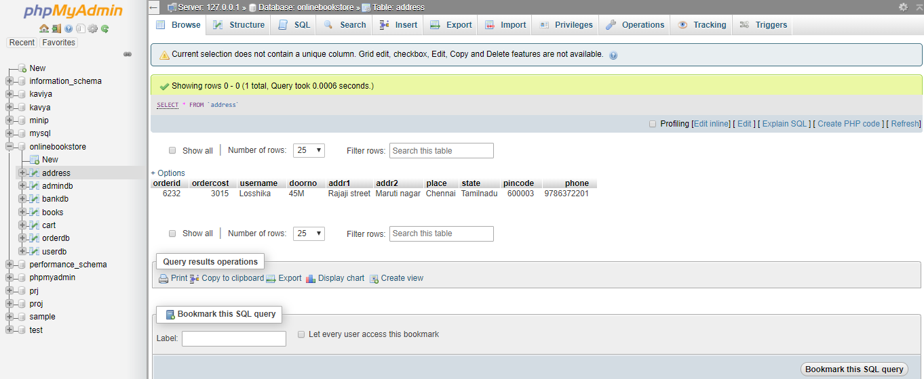

**MODE OF PAYMENT*:***

It displays the details of the order and the total cost and asks you to choose the mode of payment either ‘cash on delivery’ or through ‘credit/debit’ card.

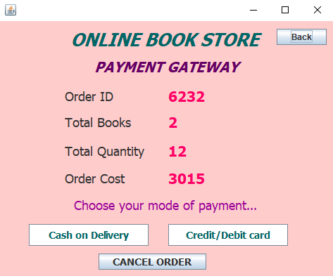

**CASE 1:**

* **CARD PAYMENT:**

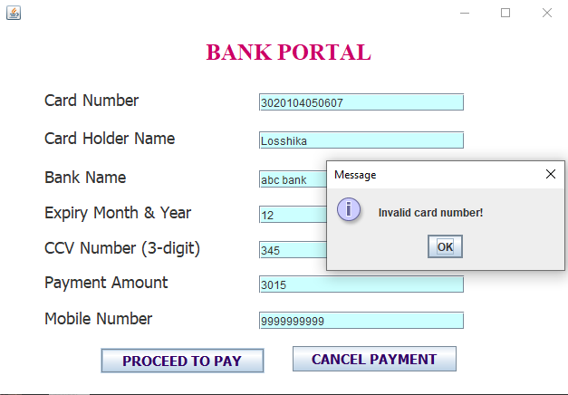It asks the customer to enter his required bank account details. The text fields can’t be empty. Once entered the details are validated he can click on ’proceed to payment’ or ‘cancel payment’ button.

**PROCEED TO VERIFICATION:**

As the ‘proceed to payment’ button is clicked, the bank portal checks whether this account and card exists in their bank (with bank DB).

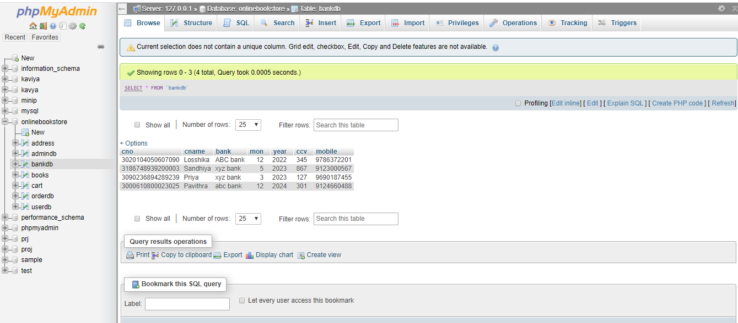

If all details are correct, an otp is generated. The user is asked to enter the correct otp in the pop up window. If wrong otp is entered the payment will not be done.

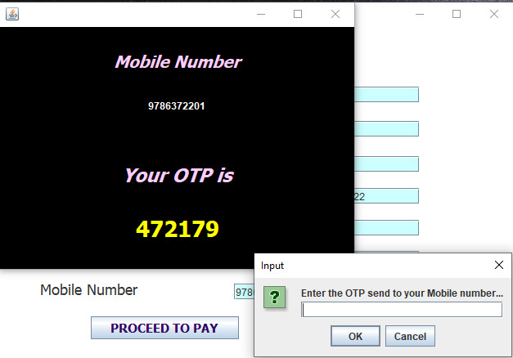

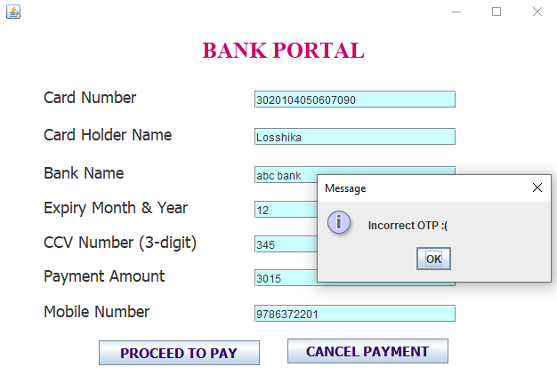

Once the OTP is entered correct, Payment is done successful and Order is confirmed.

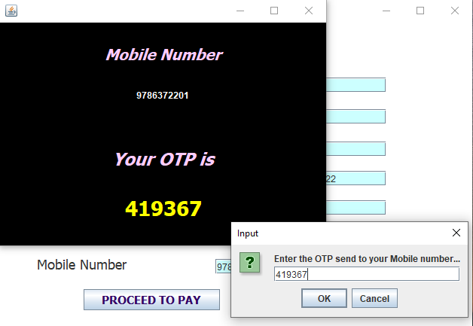

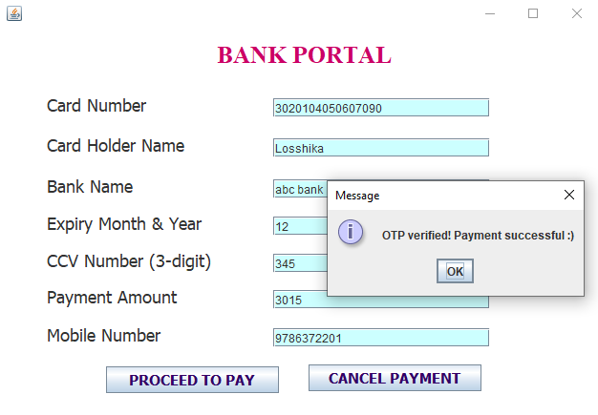

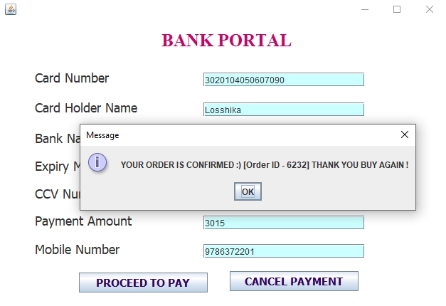

**VIEW ORDERS;**

Only if the right otp is entered payment is done , the order is placed. The user can confirm it by viewing in ‘view orders’ page.

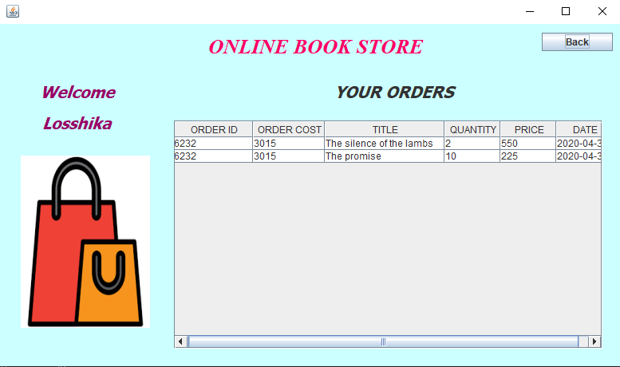

It is also updated in order DB.

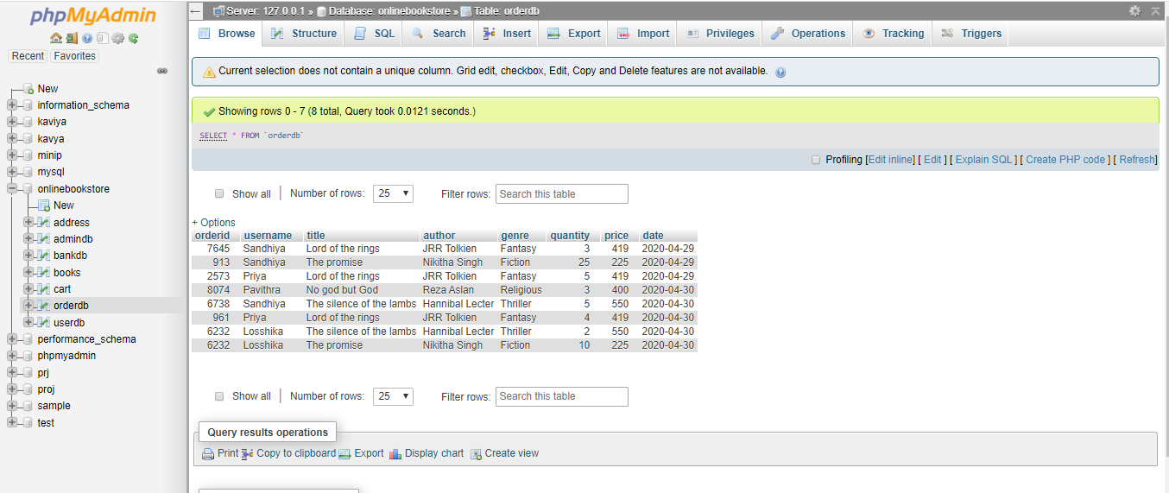

**CASE 2:**

* **CASH ON DELIVERY:**

For explaining cash on delivery we again begin from the starting process by logging in to another account.

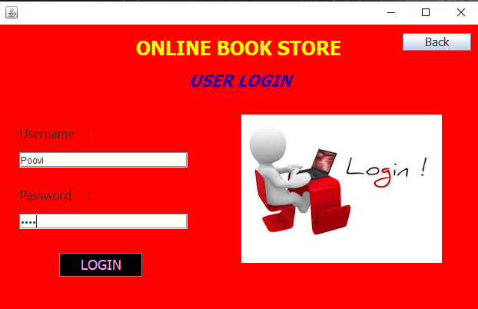

This account adds a book to cart and proceeds to order and gave delivery address.

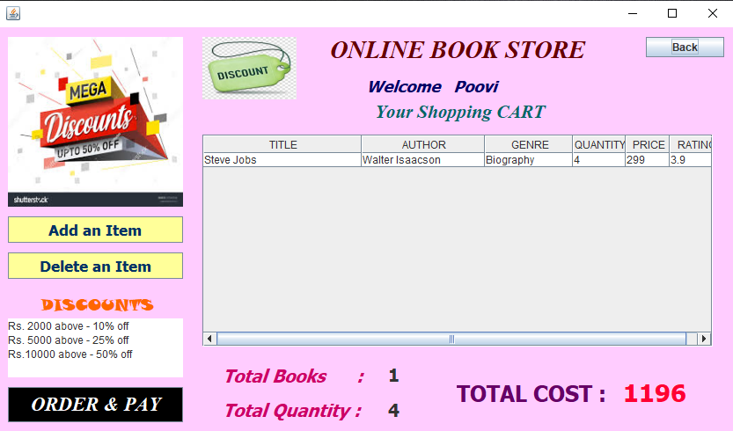

In the payment gateway, once the user selects cash on delivery option, the order is confirmed and the page is redirected to the page ‘Your Orders’.

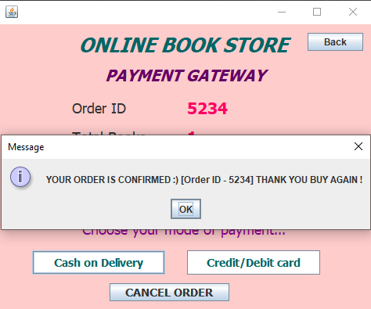

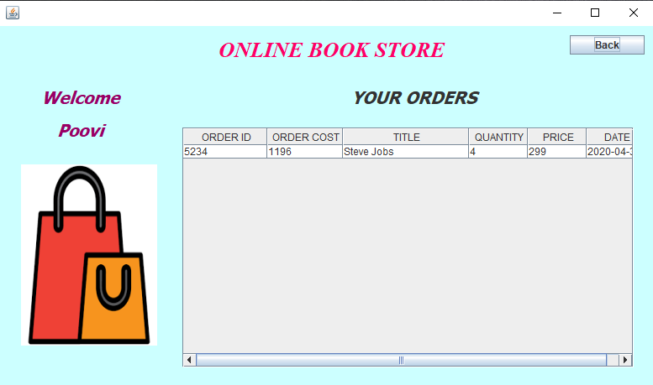

**ORDER CANCELLATION:**

Users those who proceeds to payment can also get mood swings and need to cancel their order. Users can cancel their order at any stage before payment. Once payment is done, order confirmation is done. They can cancel their order at 2 places :

* Before adding address
* Before doing payment

We can see the demo of one of the order cancellation methods.

User searches for books of genre Children and add to cart.

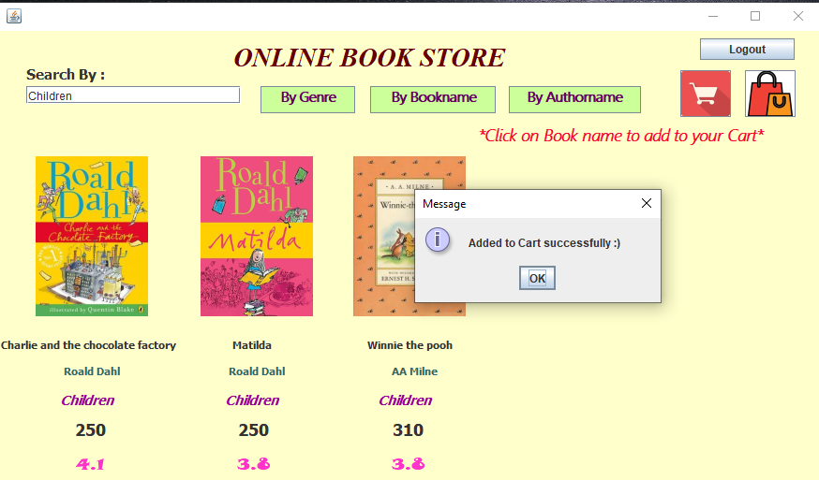

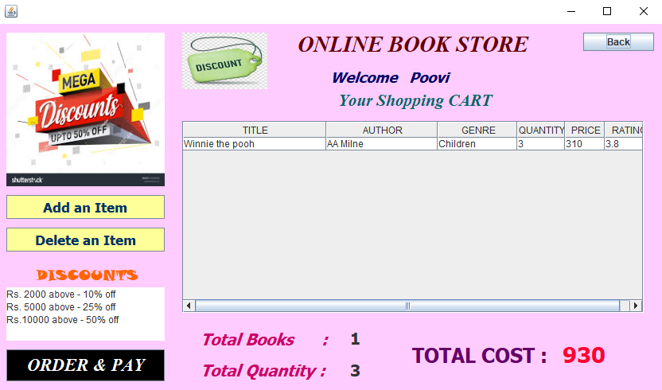

User then proceeds to order and pay. User enters the delivery address of the book he ordered and proceeds to payment gateway.

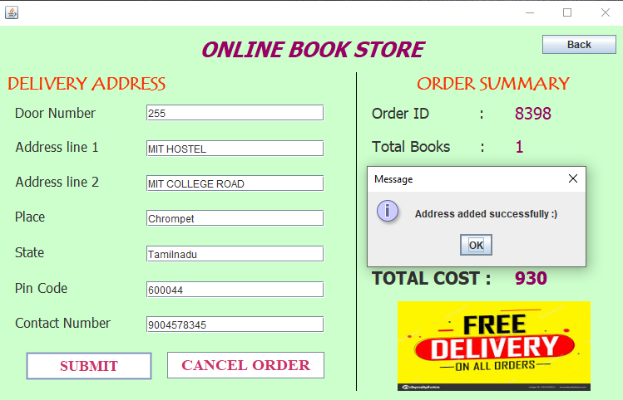

(Address then added to address DB and order details are also added to order DB)

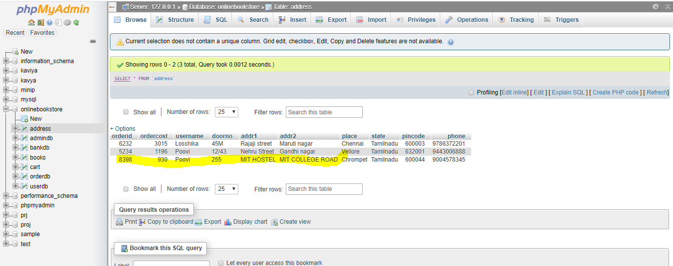

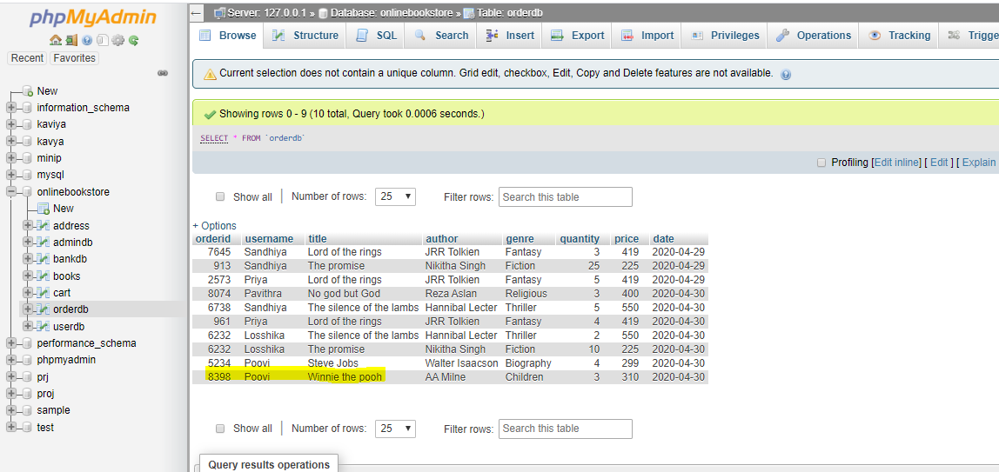

In the payment gateway, user chooses CANCEL ORDER option. Then order is cancelled and DB is updated.

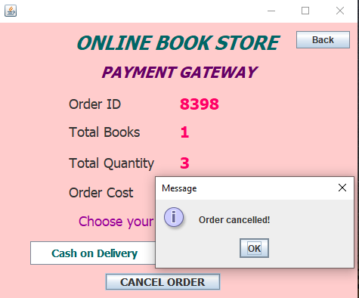

Updated address DB:

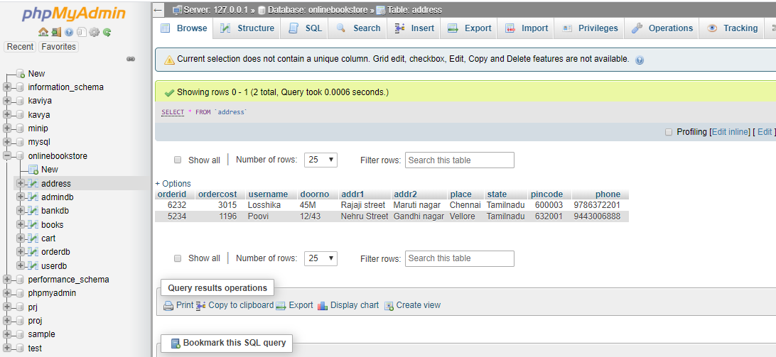

Updated order DB:

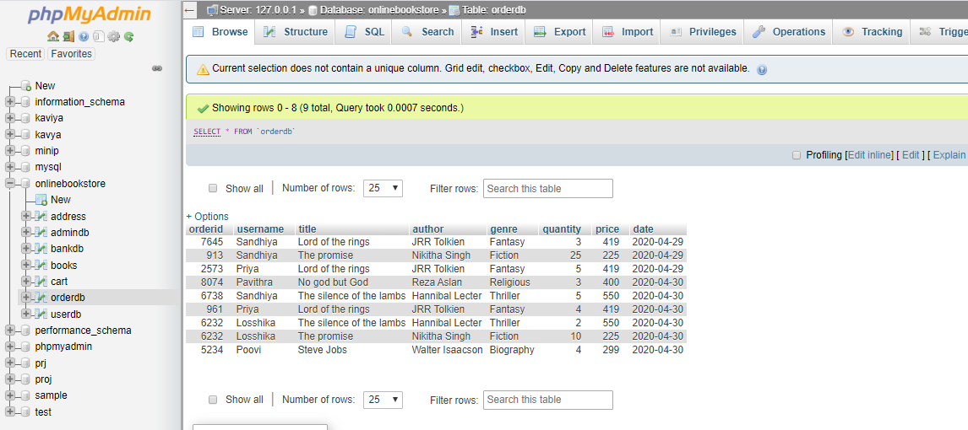

**CONCLUSION:**

This is our project and these are the techniques used in our project. This project gives a good and ease way to purchase books online. Users feel very comfortable to use this application and get delivered with the books which they are in need of.